**Portfolio report**

This model is based on Markowitz's portfolio theory, which aims to diversify the investment risk through the portfolio. This theory contains two important contents: the mean value-[Analysis of variance](https://baike.baidu.com/item/%E6%96%B9%E5%B7%AE%E5%88%86%E6%9E%90?fromModule=lemma_inlink)Methodology and portfolio[Efficient frontier](https://baike.baidu.com/item/%E6%9C%89%E6%95%88%E8%BE%B9%E7%95%8C?fromModule=lemma_inlink)Model. The efficient frontier represents the choice of all rational investors (that is, investors who are risk-averse and prefer returns)-if the risk level is the same, they will choose the portfolio that can provide the maximum return; if the expected return is the same, they will choose the portfolio with the least risk.

1. Data entry
2. Import data: 36 months of raw closing price data for ten stocks using the document "Stock Price Performance".
3. Calculate the rise and fall of each month separately to form a table. Note that the original closing price and the percentage of rise and fall are not accurate decimal places, so as to prevent the subsequent calculation from enlarging the deviation. The theory assumes that the rise and fall of an investment product in a certain month is a random event, and the rise and fall of the investment product over time is a random sequence, so its risk can be expressed by variance and standard deviation, and the expected rate of return of the investment product can be expressed by mathematical expectation (I. E. The average of the sequence).

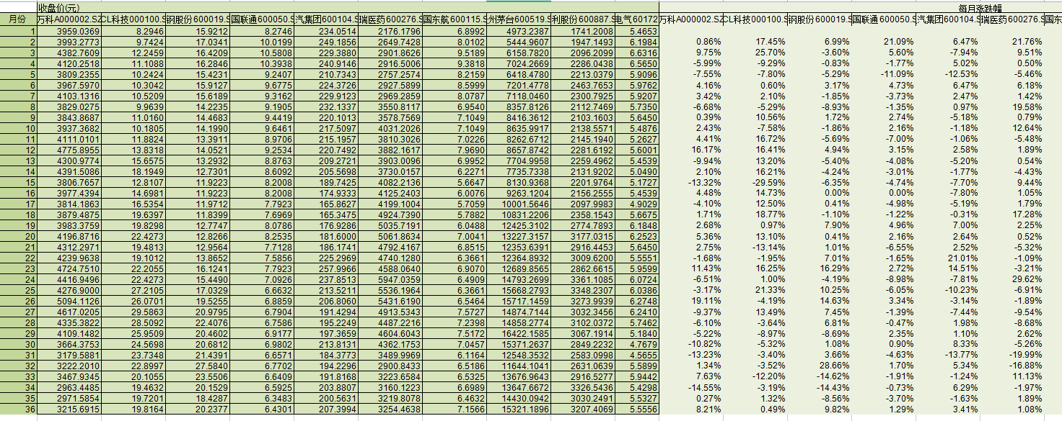

Figure I. Table of closing price and increase and decrease

1. Data preprocessing
2. Calculate the correlation

Using the correlation function correl to (), the correlation of investment products shows the degree of the same rise and fall among different investment products.

手机屏幕的截图

Figure II. Correlation Matrix

1. Calculate the average monthly increase

The average monthly increase of each stock is (), by using the equilibrium function average.

1. Calculate the average annual increase

Because the average annual increase is more commonly used to measure investment products in practice, the compound interest formula (1 + average monthly increase) ^ 12-1 is used to calculate the average annual increase of each stock, so as to see the return rate of different assets more intuitively.

1. Calculate Variance and Standard Deviation

To match the units of the average monthly increase, calculated on a monthly basis, use the standard deviation function stedv ()直 to calculate the respective standard deviation.

1. Calculate the Sharpe ratio

Without considering the deduction of risk-free asset returns, Sharpe ratio is the ratio of monthly average increase to standard deviation, which can reflect the performance-price ratio of different investment products, that is, how much return can be obtained by paying unit cost. The greater the Sharpe ratio, the greater the cost performance of the investment product.

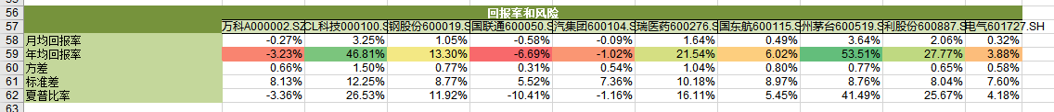

Figure III. Table of Return and Risk of Investment Products

1. Compute the covariance

Using the covariance function

1. Data processing
2. Build a portfolio model
3. Calculate the monthly and annual rate of return of the portfolio

Calculate the monthly return of the portfolio with the matrix multiplication function MMULT (portfolio weight, transpose). The calculation method of annual rate of return is the same as that of single portfolio.

1. Calculate Portfolio Standard Deviation

Figure IV. Portfolio Standard Deviation Mathematical Formula

The standard deviation of the portfolio is calculated by constructing a covariance matrix COVARIANCE. S ()计 based on the rise and fall of the portfolio.

1. Try a variety of portfolios with different goals and constraint

* Find the portfolio with the highest yield

Set constraint 1: add the weights of all stocks < = 1

Set the target: set the maximum annual rate of return for the portfolio.

* Find the portfolio with the least risk at a 15% yield

Set constraint 1: add the weights of all stocks < = 1

Set Constraint 2: Set a certain expected annual rate of return of the portfolio = 0.15

Set the target: minimum standard deviation of the portfolio

* Find the point at which the Sharpe ratio is maximum under the weight constraint, and construct it using Solver.

Set constraint 1: add the weights of all stocks < = 1

Set a target: Sharpe ratio maximum

Set constraint condition 3: each weight is greater than a certain value



Figure V. Portfolio programming solution

After comparison, the portfolio with 15% expected return is finally selected, because the Sharpe ratio is the largest, the investment performance-price ratio is the best, and the risk and return are in the acceptable range.

Figure VI. Final selected portfolio